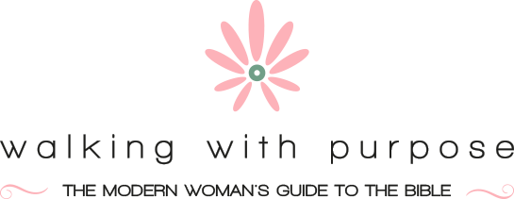

Ordering Your Priorities (OYP)

Location: St. Pius X Community Room Time: 9:30-11:30AM

Materials: The Bible and Ordering Your Priorities Study Guide

Session One | 10/06/22 | Connect Coffee Talk 1: Building the Good Life
Session Two | 10/13/22 | Priority 1: Your Relationship with God
Special Event | 10/20/22 | Lisa Brenninkmeyer Talk at St. Matthew’s in Norwalk
Session Three | 10/27/22 | Priority 2: Your Heart
Session Four | 11/03/22 | Priority 3: Your Marriage
Session Five | 11/10/22 | Priority 4: Your Children
Session Six | 11/17/22 | Priority 5: Your Home
Session Seven | 12/01/22 | Priority 6: The World Outside
Session Eight | 12/08/22 | Q&A with Father Sam & Holiday Salad Share
Session Nine | 01/05/23 | Connect Coffee Talk 2: To the Heights

No meeting on 10/20/22 due to Lisa Brenninkmeyer evening talk at St. Matthew’s in Norwalk. Separate sign up required, more info to follow.

No meeting on 11/24/22 due to Thanksgiving

