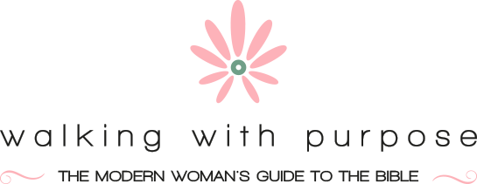

St. Pius X Walking With Purpose
OPENING YOUR HEART: THE STARTING POINT
Session 1 | 10/06/21 | Lesson 1: Connect Coffee Talk, Four Steps to WWP
Session 2 | 10/13/21 | Lesson 2: Who is Jesus Christ?
Session 3 | 10/20/21 | Lesson 3: Why is Jesus Christ Interested in My Friendship?
Session 4 | 10/27/21 | Lesson 4: Why and How Should I Pray?
Session 5 | 11/03/21 | Lesson 5: Connect Coffee Talk, God First Place in All Things
Session 6 | 11/10/21 | Lesson 6: Who is the Holy Spirit?
Session 7 | 11/17/21 | Lesson 7: Why Should I Read the Bible?
Session 8 | 12/01/21 | Lesson 8: What is Grace and What Difference Does It Make?
Session 9 | 01/0/22 | Lesson 9: What are the Limits of Christ's Forgiveness?
Session 10 | 01/05/22 | Lesson 10: Connect Coffee Talk, Your Heart - You Are Captivating
Session 11 | 01/12/22 | Lesson 11: What Does the Sacrament of Penance Have to Do with My Friendship With Christ?
Session 12 | 01/19/22 | Lesson 12: What Does the Eucharist Have to Do with My Friendship with Christ?
Session 13 | 01/26/22 | Lesson 13: How Can I Conquer My Fears?
Session 14 | 02/02/22 | Lesson 14: Connect Coffee Talk, Marriage - Transformed by Grace
Session 15 | 03/09/22 | Lesson 15: What is the Role of Suffering in My Life?
Session 16 | 03/16/22 | Lesson 16: What Does Mary Have to Do With My Relationship with Christ?
Session 17 | 03/23/22 | Lesson 17: Can God Really Change Me or Is That Just Wishful Thinking?
Session 18 | 3/30/22 | Lesson 18: Children - Connect Coffee Talk, Reaching Your Child's Heart
Session 19 | 04/06/22 | Lesson 19: What Challenges Will I Face In My Efforts to Follow Jesus More Closely?
Session 20 | 04/20/22 | Lesson 20: What is the Relevance of the Church In My Life?
Session 21 | 04/27/22 | Lesson 21: How Do I Read the Bible in a Meaningful Way?
Session 22 | 05/4/22 | Lesson 22: Connect Coffee Talk, Outside Activities - Set the World on Fire/End of Year Potluck Dinner

No session on 11/24/21 due to Thanksgiving
Assumes 4 week break for Christmas (12/8/21, 12/15/21, 12/22/21, 12/29/21)
No session on 2/16/22 due to winter break
No session on 4/13/22 due to spring break and Holy Thursday

