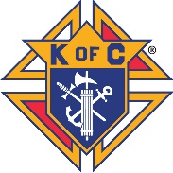
St. Pius X K of C Council 16347 Fundraiser
Because of the many charitable and community activities the K of C Council 16347 sponsors, there are always expenses incurred. By making available non-expiring gift cards to the HoneyBaked franchise, we believe would be a convenience for families while at the same time gain a commission for our Council. We know various special occasions occur during the spring season, such as birthdays, St. Patrick Parties, Easter Meal, first communion/confirmation celebrations and even graduations gatherings; all usually include food. And it makes a great gift anytime for family or friends.
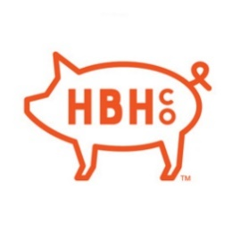
How it works: It's easy!
Just go to our link: https://honeybakedfundraising.com/fundraisers/stpiusxkofc to purchase the gift card(s) (Either a plastic or electronic card) which comes in denominations of $25, $50, $75 and $100. Your choice(s) will be mailed directly to you.
Or write a check to the “K of C St Pius Council 16347” indicating what denomination of card(s) and the number of each desired – we will order your card(s) and make available for pick up. Please make sure your address and phone number is on the check; drop in collections basket or mail to the parish office Att: K of C Council 16347.
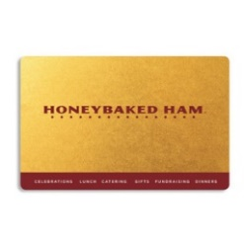
How to use the gift card: Various options!
- Purchase at the nearby store the desired food items: (You can phone ahead to learn if the order is available and /or ready; some may need to be prepared or delivered to store)
Address: 1270 Boston Post Rd, Milford, CT 06461 --- Opposite Milford’s Connecticut Post Mall
Hours: Week Days 9am to 6pm; Saturday 10am to 6pm; Sunday 11am to 5pm. (203) 874-4800
    - Order on line the desired merchandise. It will be shipped to the designated address; naturally there will be a shipping charge.
    - Gift a card to a family member or friend.

NOTE: If food purchase total is less than face value of card, the balance remains on card for future use, or if cost is more than value of the card then one pays the difference.
What merchandise is available? Visit the Honeybaked Ham website: www.HoneyBakedOnLine.com to view the scrum shish options and possible cost:
- Turkeys and hams either with or without the bone; many are pre-sliced; size are half or full
- Other meat options are also available
- Variety of Side Dishes
- Yummy Desserts
- Lunch sandwiches and salads only available directly from a store
Questions:
Call or E-Mail Ralph Burke: (203) 583-9212 or RalphBurke@optonline.net

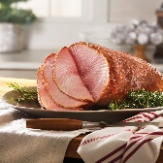
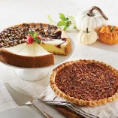
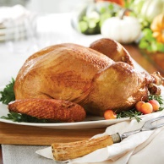
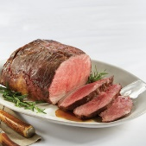
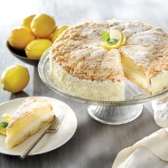
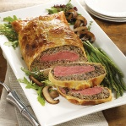
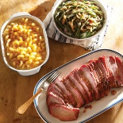

ORDER CARD(S): https://honeybakedfundraising.com/fundraisers/stpiusxkofc

