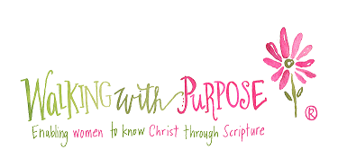

2017-2018 Opening Your Heart Registration Form

Name
Email Address
Street Address
City, State, Zip
Home Phone
Mobile Phone
Emergency Contact Name/Phone #
Birth Date: Month/Day
Home Parish
Childcare needed (Y/N)
# Children and Ages
Willing to volunteer to help with childcare if necessary (Y/N)
Seating request (1-2 friends)
Scholarship information | ( ) scholarship requested for course fee  ( ) scholarship donation offered $______
Payment ($25) | ( ) Cash ( ) Check Check # _____

Program cost is $25. Please make checks payable to: St. Pius X Church
Please return form and check to church office or mail to: St. Pius X Church
834 Brookside Dr, Fairfield, CT 06824, Attention: Walking With Purpose
Please order the Opening Your Heart study guide from the WWP website: http://wwp-store.myshopify.com

